**Lab Manual for Computer Communication and Networking**

**Lab No. 6**

**Spanning Tree Protocol**

**BAHRIA UNIVERSITY KARACHI CAMPUS**

**Department of Software Engineering**

**COMPUTER COMMUNICATION & NETWORKING**

**LAB EXPERIMENT # 6**

Spanning Tree Protocol

**OBJECTIVE: -**

* To understand that how to avoid looping by using STP protocol.

**THEORY: -**

The Spanning Tree Protocol (STP) is a [link layer](http://en.wikipedia.org/wiki/Link_layer) [network protocol](http://en.wikipedia.org/wiki/Network_protocol) that ensures a loop-free [topology](http://en.wikipedia.org/wiki/Network_topology) for any [bridged](http://en.wikipedia.org/wiki/Bridging_(networking)) [LAN](http://en.wikipedia.org/wiki/Local_area_network). It is based on an [algorithm](http://en.wikipedia.org/wiki/Algorithm) invented by [Radia-Perlman](http://en.wikipedia.org/wiki/Radia_Perlman) while working for [Digital Equipment Corporation](http://en.wikipedia.org/wiki/Digital_Equipment_Corporation). In the [OSI model](http://en.wikipedia.org/wiki/OSI_model) for computer networking, STP falls under the [OSI layer-2](http://en.wikipedia.org/wiki/Data_link_layer). Spanning tree allows a network design to include spare (redundant) links to provide automatic backup paths if an active link fails, without the danger of bridge loops, or the need for manual enabling/disabling of these backup links. Bridge loops must be avoided because they result in flooding the network.

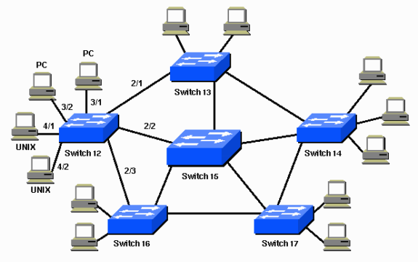

**Fig 13.1** Spanning Tree Protocol

With STP, the key is for all the switches in the network to elect a root bridge that becomes the focal point in the network. All other decisions in the network, such as which port to block and which port to put in forwarding mode, are made from the perspective of this root bridge. A switched environment, which is different from a bridge environment, most likely deals with multiple VLANs. When you implement a root bridge in a switching network, you usually refer to the root bridge as the root switch. Each VLAN must have its own root bridge because each VLAN is a separate broadcast domain. The roots for the different VLANs can all reside in a single switch or in various switches.

Note: The selection of the root switch for a specific VLAN is very important. You can choose the root switch, or you can let the switches decide, which is risky. If you do not control the root selection process, there can be suboptimal paths in your network.

All the switches exchange information for use in the root switch selection and for subsequent configuration of the network. Bridge protocol Computer units (BPDUs) carry this information. Each switch compares the parameters in the BPDU that the switch sends to a neighbor with the parameters in the BPDU that the switch receives from the neighbor.

In the STP root selection process, less is better. If Switch A advertises a root ID that is a lower number than the root ID that Switch B advertises, the information from Switch A is better. Switch B stops the advertisement of its root ID, and accepts the root ID of Switch A.

A STP usually works in the following four steps:

1. Elect Root Switch
2. Tag Root Ports
3. Tag Designated Ports
4. Block all remaining ports.

**Root Port:** Port of a switch directly connected to the root switch or through another switch.

**Designated Port:** Port on the other end of a root port.

**NETWORK TOPOLOGY: -**

It shows that how to setup a network among 3 switches and their devices. Which transform a bridge in which devices were entertain through there priority level and their MAC-address.

Bridge ID = Priority + MAC address + VLAN.

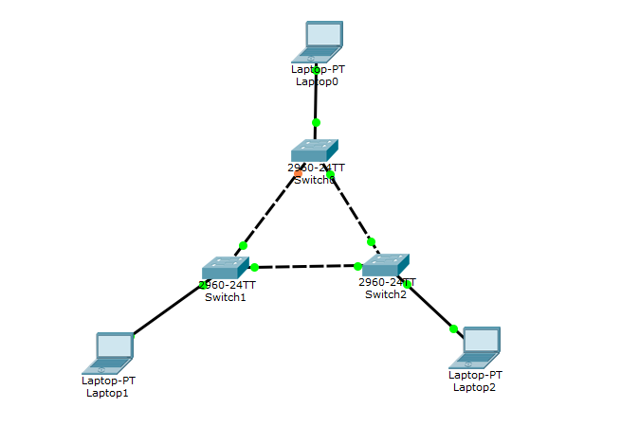

**Fig 13.2** Network among 3 Switches and Devices

**PROCEDURE AND OBSERVATION: -**

The above network shows Switch2 as the root switch and a redundant path between Switch0 and Switch1 deactivated by the STP. Each PC in this network will be able to ping all others. The beauty of STP is such that if a working link is broken or deactivated, the redundant link automatically becomes active and resumes the traffic flow.

**EXAMPLE: -**

**Switch>en**

**Switch#config t**

**Enter configuration commands, one per line. End with CNTL/Z.**

**Switch(config)#int fa0/3**

**Switch(config-if)#shutdown**

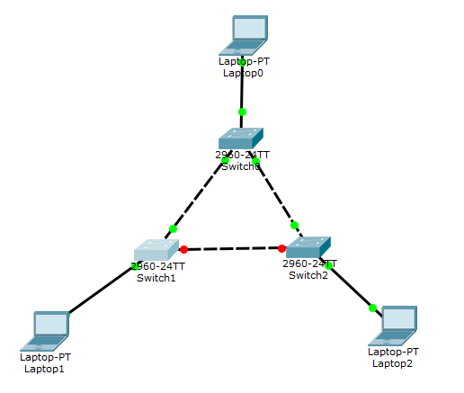

**CHANGING PRIORITY OR ROOT SWITCH: -**

Since root switch is selected with respect to the priority of the switch amongst other factors, to change the default root switch to a desired switch, the priority of a switch can be lowered.

**Switch(config)#spanning-tree vlan 1 priority ?**

**<0-61440> bridge priority in increments of 4096**

Enter a priority number as a multiple of 4096 to set a lower priority than the current root switch.

Another way to change the root switch from default to desired is by directly running the following command on the desired root switch.

**Switch(config)#spanning-tree vlan 1 root primary**

**RAPID STP:**

During the transition to the redundant port, the STP processing takes a lot of time that can result in the loss of several Computer packets. To avoid this loss, the following command is run to implement the rapid spanning-tree protocol.

**Switch(config)#spanning-tree mode rapid-pvst**

**QUESTIONS: -**

* **Analyze the above network, deactivate another working interface and monitor the shift to the redundant interface. Also, change the root switch to a switch of your choice and implement the rapid STP and finally show the pinging results.**

**TIME BOXING:**

|  |  |  |
| --- | --- | --- |
| **Activity Name** | **Activity Time** | **Total Time** |
| **Instruments Allocation + Setting up Lab** | 10 mints | 10 mints |
| **Walk through Theory & Tasks (Lecture)** | 60 mints | 60 mints |
| **Implementation & Practice time** | 90 mints | 80 mints |
| **Evaluation Time** | 20 mints | 20 mints |
|  | Total Duration | 180 mints |

**Teacher Signature**: ________________________

**Student Registration No**: ________________________